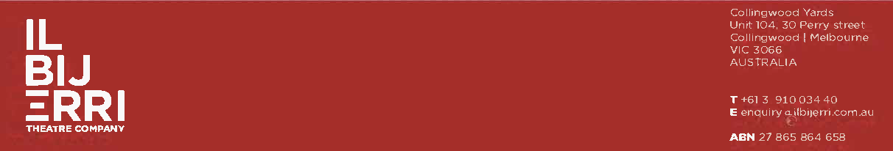

POSITION TITLE | General Manager
SALARY | $90,000 to $100,000 pa commensurate with experience plus superannuation
POSITION TYPE | Full time, initial one year contract subject to a three-month probationary period
LOCATION | Hybrid - Collingwood Yards Arts Precinct & home
REPORTS TO | Executive Director and Artistic Director
FOR ENQUIRIES | darise@ilbijerri.com.au

PLEASE NOTE: This is a First Peoples (Aboriginal and/or Torres Strait Islander) prioritised position, but candidates with appropriate experience and/or diverse lived experiences are also encouraged to apply.

If you meet some but not all the below criteria, we warmly encourage you to reach out to us to discuss your application.
ABOUT ILBIJERRI THEATRE COMPANY
ILBIJERRI Theatre Company is one of three leading First Peoples theatre companies in Australia. We have been telling our stories our ways for over 30 years. ILBIJERRI creates, presents and tours powerful and engaging theatre by First Peoples. Deep listening with Community and Country is central to our work. We take seriously our role as cultural leaders; we believe First Peoples voices are powerful in determining the future of Australia. We're looking for people who want to be a part of this.

ABOUT THE ROLE
The General Manager is a senior position within ILBIJERRI Theatre Company responsible for the internal running of a busy arts organisation. The role will manage and oversee all day-to-day operations and administration of ILBIJERRI and will continuously improve processes and procedures as the company grows.

PREFERRED SKILLS & EXPERIENCE
- An understanding of First Peoples’ cultural values, practices, and beliefs. Experience in a First Peoples context would be ideal
- Strong financial knowledge and experience gained perhaps in a previous accounting/bookkeeping role
- High level business management skills in HR, risk management, IT, development and implementation of policies and procedures and office administration
- Ability to build strong relationships with varying stakeholders such as Community, board members, government and suppliers
- Highly organised, with thoroughness and attention to detail. Able to prioritise work and meet deadlines

KEY RESPONSIBILITIES

Financial management and compliance
- Monitor and accurately report all financial aspects of the company against budget for the executive team and board
- Regular provision of income statements, balance sheets and other financial data both internally to staff and board, and externally to funders to fulfil contractual obligations and satisfy grant application requirements
- Develop an annual organisation budget with monthly reforecasting jointly with the Executive Director
- Manage the work of the external accountant and bookkeeper including oversight on payroll, accounts payable and receivable, credit card reconciliations, financial reporting, and tracking of grant funds
- Audit liaison with the external accountant and auditor to help prepare audited company and project financials
- Coordinate and help prepare operational funding applications, as well as oversee the collection of statistical data to provide to operational funders to meet reporting requirements
- Ensure compliance with ACNC, CAV, ROCO etc is always maintained

Human resources and risk management
- Deliver day to day HR functions and develop, update and implement HR processes and procedures jointly with the Executive Director
- Develop standardised contracts for staff and renew when necessary
- In conjunction with the Executive Director, oversee the probationary and performance review and exit interview processes
- Develop and continually review and update the company’s strategic risk register

Governance
- Schedule all board and subcommittee meetings throughout the year in consultation with board members
- Draft agendas for the board and subcommittee meetings and prepare supporting papers for distribution
- Take minutes at each board and subcommittee meeting
- Schedule and organise the Annual General Meeting and all appropriate paperwork in accordance with legislation and the cooperative rules
- Provide administrative support to the board and its subcommittees as required

Office management
- In conjunction with the Executive Director, develop, implement and update company policies and procedures ensuring cultural safety and First Peoples protocol is adhered to at all times
- Create an up-to-date policies and procedures manual for the organisation jointly with the Executive Director
- Oversee the day to day running of the office in terms of leasing, asset management, security, storage, insurance etc, liaising with service providers when required
- Manage IT and data management including relationships with external contractors

APPLICATION PROCESS
Please provide:
- Your CV
- A cover letter of no more than two pages addressing the preferred skills and experience

Please submit your applications promptly as we will be reviewing applications as soon as they come in and interviewing suitable candidates shortly thereafter.

Applications close Friday 12 April.

